- Write a program in R to perform Classification using decision tree.
library(datasets)
library(caTools)
library(party)
library(dplyr)
library(magrittr)

data("readingSkills")
head(readingSkills)
nativeSpeaker age shoeSize score
1 yes 5 24.83189 32.29385
2 yes 6 25.95238 36.63105
3 no 11 30.42170 49.60593
4 yes 7 28.66450 40.28456
5 yes 11 31.88207 55.46085
6 yes 10 30.07843 52.83124
sample_data = sample.split(readingSkills, SplitRatio = 0.8)
train_data <- subset(readingSkills, sample_data == TRUE)
test_data <- subset(readingSkills, sample_data == FALSE)

model<- ctree(nativeSpeaker ~ ., train_data)
plot(model)
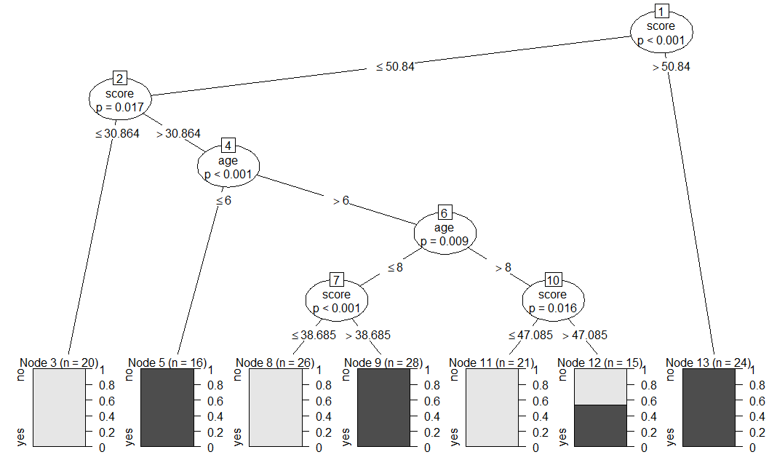
# testing the people who are native speakers
# and those who are not
predict_model<-predict(model, test_data)

# creates a table to count how many are classified
# as native speakers and how many are not
m_at <- table(test_data$nativeSpeaker, predict_model)
m_at
predict_model
no yes
no 24 2
yes 0 24
accuracy_Test <- sum(diag(m_at)) / sum(m_at)
print(paste('Accuracy for test is found to be', accuracy_Test))
[1] "Accuracy for test is found to be 0.96"

